ARCH TECHNOLOGIES
Cyber Security Internship Report

MONTH 2

INTERNSHIP DETAILS
Name | Humza Ahmed
Domain | Cyber Security
Email | humzaahmed798@gmail.com
Organization | Arch Technologies
Submission | 25th May 2026

TASK 4
Credit Card Fraud Detection System
Machine Learning with Random Forest | SMOTE | ROC-AUC 0.9717

1. Objective
Task 4 involved building a complete Credit Card Fraud Detection System using machine learning techniques. The project used the Kaggle ULB Credit Card Fraud dataset a real-world dataset containing 284,807 transactions from European cardholders, of which only 492 (0.172%) are fraudulent. The goal was to train a model capable of detecting fraudulent transactions with high accuracy while managing the extreme class imbalance inherent in financial fraud data.

2. Dataset Overview
The dataset was sourced from Kaggle (mlg-ulb/creditcardfraud) and has the following characteristics:

Property | Details
Total Transactions | 284,807
Legitimate Transactions | 284,315 (99.827%)
Fraudulent Transactions | 492 (0.173%)
Class Imbalance Ratio | 578:1 (legitimate to fraud)
Features | 30 (V1–V28 PCA-transformed, Time, Amount)

3. Tools & Libraries Used
- Python (Google Colab environment)
- pandas, numpy data loading and manipulation
- scikit-learn model training, evaluation metrics, train/test split
- RobustScaler feature scaling resistant to outliers
- RandomForestClassifier ensemble learning model
- SMOTE (imbalanced-learn) Synthetic Minority Over-sampling Technique
- matplotlib, seaborn data visualisation (confusion matrix, ROC curve, feature importance)

4. Implementation Walkthrough

4.1 Data Loading & Class Distribution
The dataset was downloaded via the Kaggle API and loaded into a pandas DataFrame. The severe class imbalance was immediately apparent:
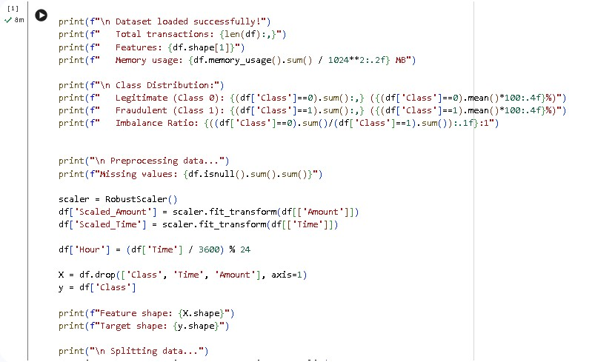
Figure: Data loading code class distribution analysis and preprocessing pipeline

4.2 Preprocessing & Feature Engineering
The Amount and Time features were scaled using RobustScaler, which is resilient to outliers a critical choice for fraud data where transaction amounts vary enormously. An additional Hour feature was engineered from Time to capture time-of-day patterns in fraudulent activity.

4.3 Train/Test Split
The data was split 70/30 (training/test) with stratification to ensure both sets maintain the same fraud ratio. The training set contained 199,364 transactions and the test set contained 85,443 transactions.
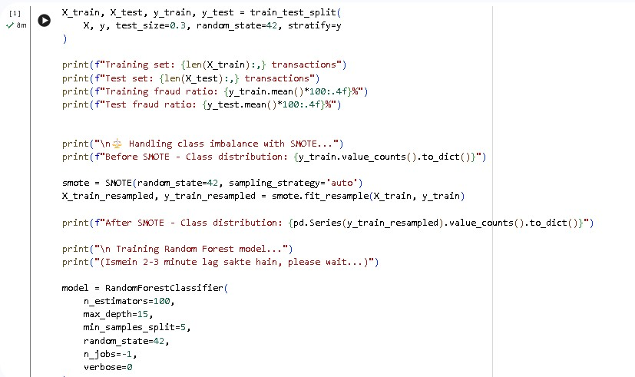
Figure: Train/test split with SMOTE class balancing applied to the training set

4.4 Handling Class Imbalance with SMOTE
SMOTE (Synthetic Minority Over-sampling Technique) was applied to the training set to address the extreme class imbalance. SMOTE generates synthetic fraud examples by interpolating between existing fraud samples rather than simply duplicating them, resulting in a balanced training set where the model can learn fraud patterns effectively without bias towards the majority class.

4.5 Random Forest Model Training
A Random Forest Classifier was trained with the following configuration:

Hyperparameter | Value
n_estimators (trees) | 100
max_depth | 15
min_samples_split | 5
random_state | 42
n_jobs | -1 (all CPU cores)

5. Model Performance Results
The model was evaluated on the held-out test set of 85,443 transactions. The results demonstrate strong fraud detection capability:

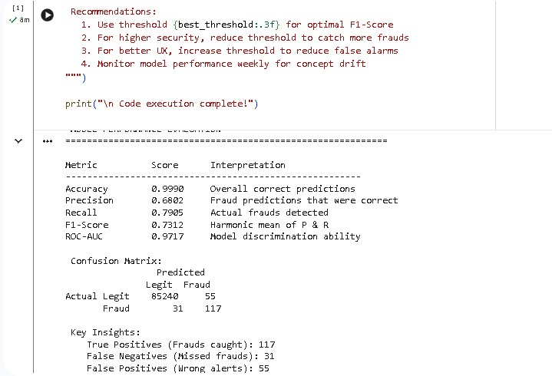
Figure: Model performance evaluation output metrics, confusion matrix, and key insights

Metric | Score
Accuracy | 0.9990
Precision | 0.6802
Recall (Detection Rate) | 0.7905
F1-Score | 0.7312
ROC-AUC | 0.9717

5.1 Confusion Matrix & ROC Curve
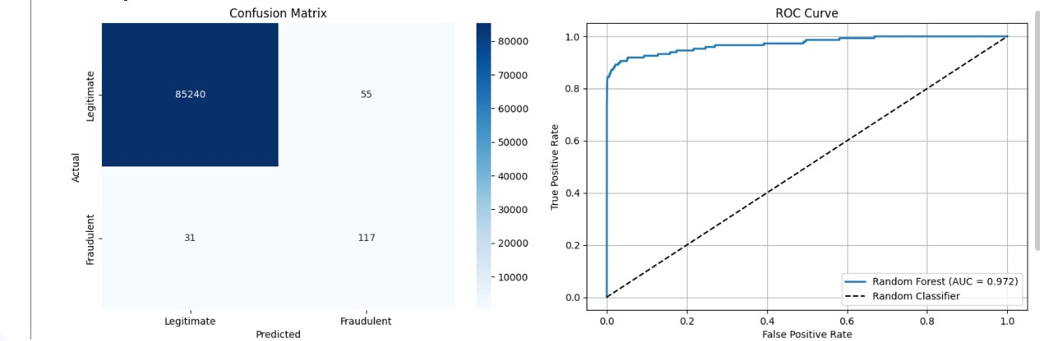
Figure: Confusion Matrix (left) and ROC Curve with AUC = 0.972 (right)

5.2 Feature Importance & Probability Distribution
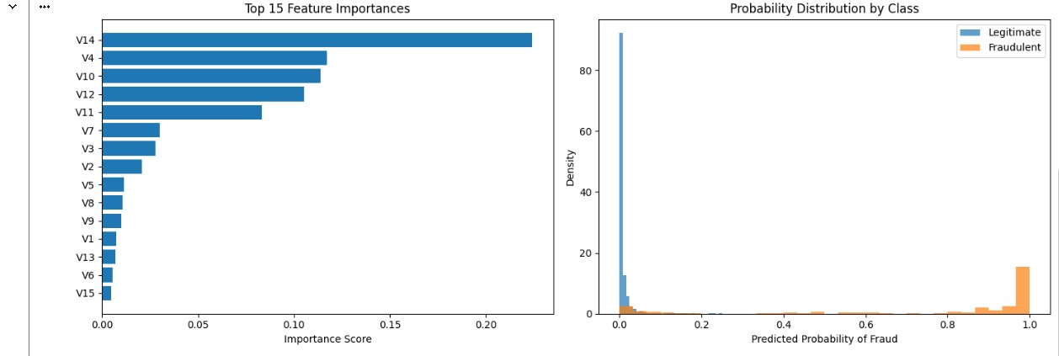
Figure: Top 15 Feature Importances (left) and Probability Distribution by Class (right)

Feature V14 emerged as the most significant predictor of fraud, followed by V4, V10, and V12. These are PCA-transformed components of the original transaction features. The probability distribution chart confirms excellent class separation legitimate transactions cluster near 0.0 while fraudulent ones cluster near 1.0.

5.3 Optimal Threshold Analysis
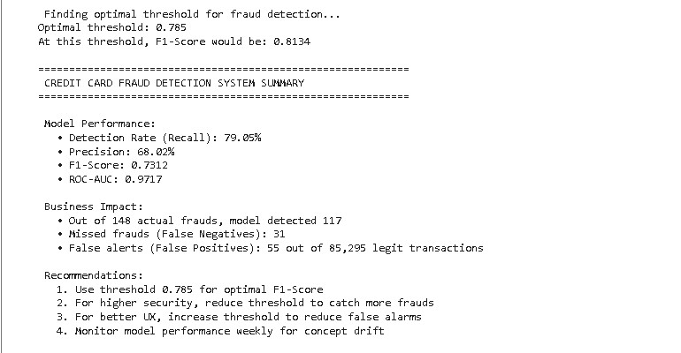
Figure: Final summary optimal threshold 0.785, F1-Score 0.8134, business impact analysis

Optimal Threshold Finding
Through precision-recall curve analysis, the optimal classification threshold was determined to be 0.785, at which point the F1-Score reaches 0.8134. Tuning this threshold allows the system to be adjusted for different operational priorities a lower threshold catches more fraud while a higher threshold reduces false alerts for customers.

6. Detailed Classification Report
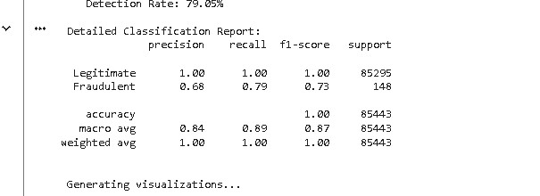
Figure: Detailed classification report precision, recall, and F1-score per class

The model achieves perfect precision and recall (1.00) on legitimate transactions, which is expected given their overwhelming majority in the dataset. For fraudulent transactions, a precision of 0.68 and recall of 0.79 represent a strong result considering the 578:1 class imbalance without SMOTE, these figures would be significantly worse.

7. Business Impact Analysis
Business Metric | Value
Actual frauds in test set | 148
Frauds caught (True Positives) | 117
Missed frauds (False Negatives) | 31
False alerts on legit transactions | 55 out of 85,295
Detection Rate | 79.05%

With a detection rate of 79.05%, the model successfully identified 117 out of 148 fraudulent transactions. Only 55 legitimate transactions were incorrectly flagged a false positive rate of just 0.06%, which is an acceptable level for a real financial institution. The 31 missed frauds represent the remaining challenge, addressable by lowering the classification threshold.

8. Recommendations
- Use a classification threshold of 0.785 for the optimal balance between precision and recall (F1 = 0.8134)
- Reduce the threshold below 0.785 in high-security environments where catching all fraud is the priority, accepting more false alerts
- Increase the threshold in customer-facing applications where minimising false alarms and friction is more important
- Schedule weekly model retraining to detect concept drift fraud patterns evolve continuously
- Consider an ensemble approach combining Random Forest with XGBoost or a neural network for improved precision on the fraud class

9. Key Takeaways
- Extreme class imbalance (578:1) is the core challenge in fraud detection SMOTE effectively addresses this by generating synthetic minority samples
- Random Forest with 100 trees and max_depth=15 delivers ROC-AUC of 0.9717 strong discrimination ability between fraud and legitimate transactions
- RobustScaler is the correct preprocessing choice for financial data due to outlier resistance
- Feature V14 is the single most important predictor of fraudulent activity in this dataset
- Threshold tuning is a powerful post-training tool to align model behaviour with business requirements

